The EQ-i2.0 Model

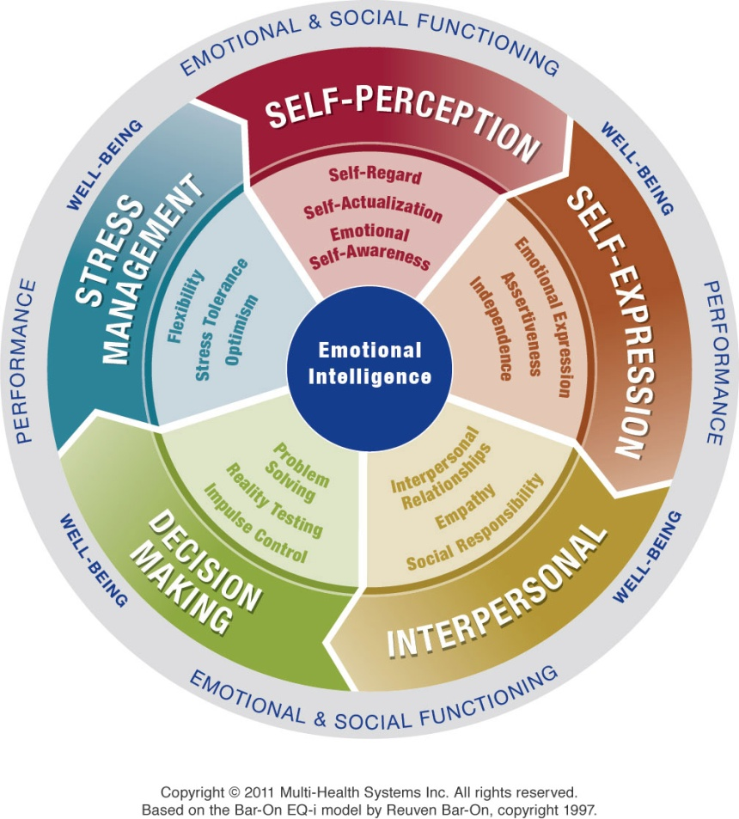

The overall result of well-developed emotional intelligence is healthy emotional and social functioning, which is linked to your well-being (and happiness). There are several facets that work together to produce an effective level of emotional and social functioning and well-being.

The model starts with self-perception. Understanding yourself allows you to better express yourself. This leads to healthier interactions with others, which then leads to making good decisions. Making good decisions allows you to manage stress better, which leads to understanding your emotions better and so on. It is important to consider that the EQ-i2.0model of emotional intelligence is dynamic and:

* Each facet relies on and influences the others
* Each facet works together to create healthy emotional intelligence – none is more important than the other
* The model is circular in nature, there is no start or end point

Collectively, the EQ-i2.0 model of emotional intelligence produces an overall snapshot of one’s emotional intelligence.